**Payroll Application internal software details**

**Requirements**:

Software should be able to compute payroll expenses for typical small business employer. Initially the software will support computation of all federal expenses as well as expenses for business located in California. In future it will support businesses located in other states.

**Design approach**

There are three main components in this application.

1. PayrollLibrary module.

The payroll computation is implemented in PayrollLibrary module written in Java using Intellij IDEA community edition. This module performs all the computation for the data that is passed to it using in built logic and external “data” that changes year to year.

1. External “data” files.

The “data” directory contains information that is adjusted annually by Federal and State governments. Federal and state withholding that contain large number of files for computation are stored by year in withholding directory, rest of the files are at root directory. **The advantage of data file externalized by the application is anyone can update it without software code change, that is, without need for software upgrade.**

1. User interface and database access module (main application).

The user interface is written in Java (Swing) using NetBeans IDE. The design tries to emulate Model View View Model (MVVM) design pattern. Each UI tab is supported by View Model that communicates to DB and gets or updates the data using Model.

The database used to store application data is SQLiteDB. The community edition of the database does not support encryption or any security, to best of my understanding; hence key sensitive data like SSN, Date of Birth etc. is not stored. In future when a secure DB is used more security will be implemented. The code change required to migrating to secured DB is expected to be minimal.

**Junit testing**

**PayrollLibrary** which is core of the tax computation is very heavily tested using Junit test.

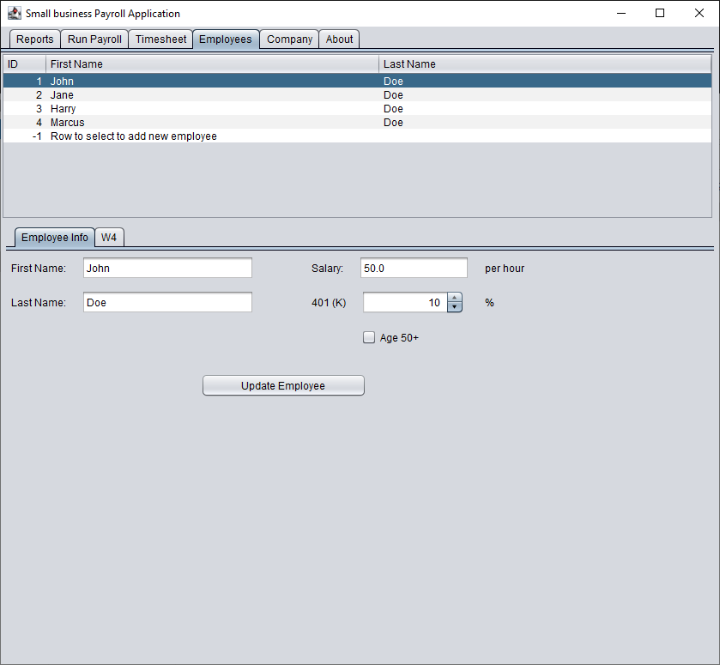

**Typical Sequence diagram to fill data in the UI tabs**

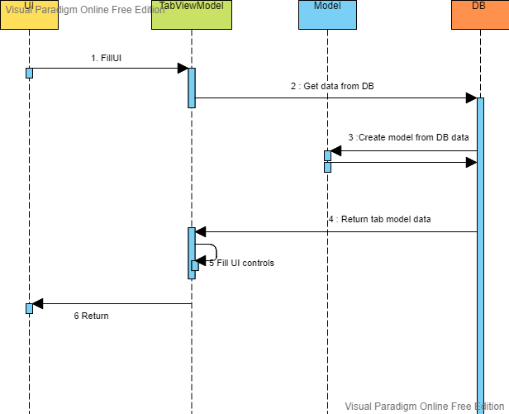

**Typical Sequence diagram to save data entered in UI tab to DB**

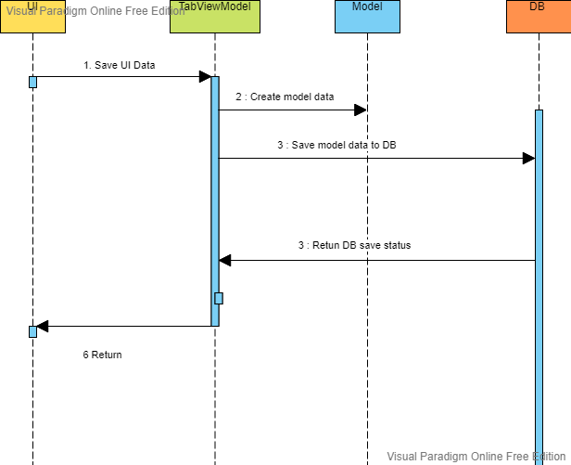

**Main classes used in Payroll UI Application**

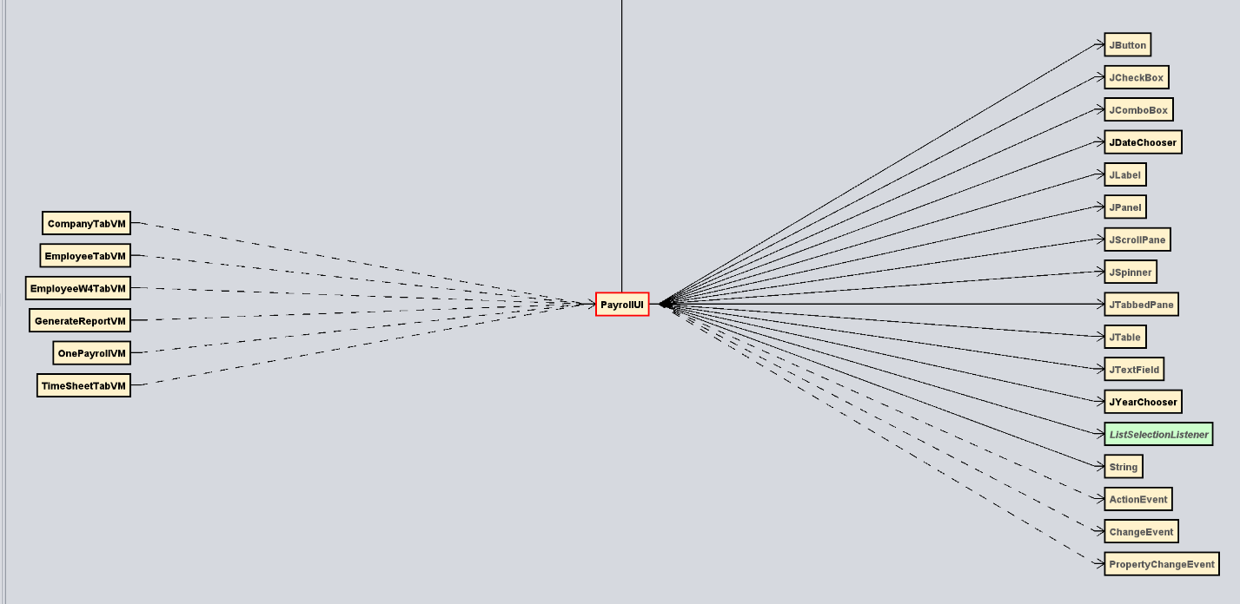

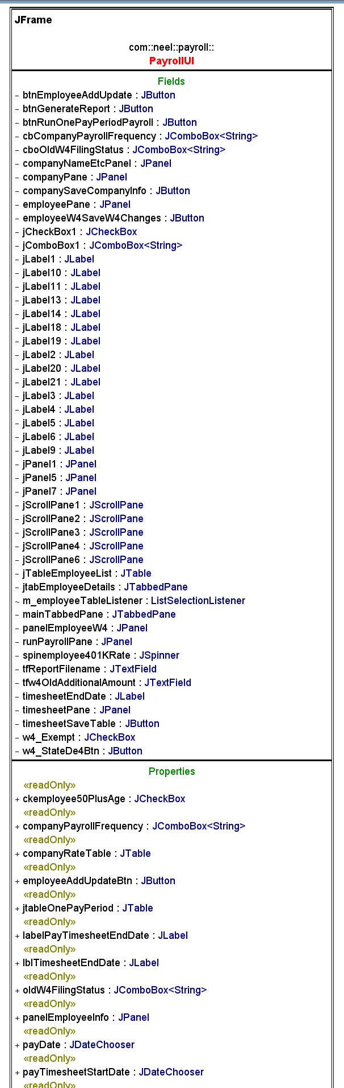 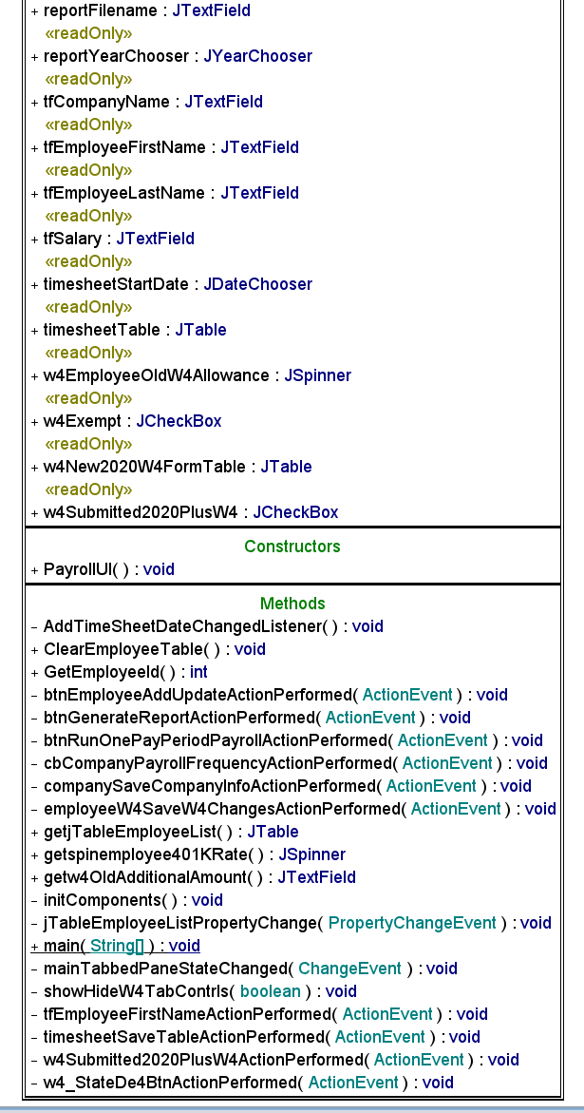

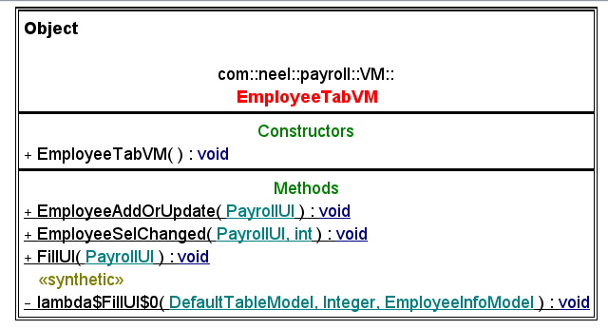

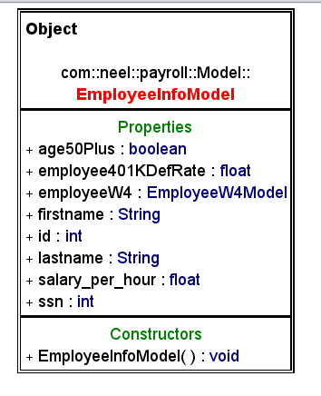

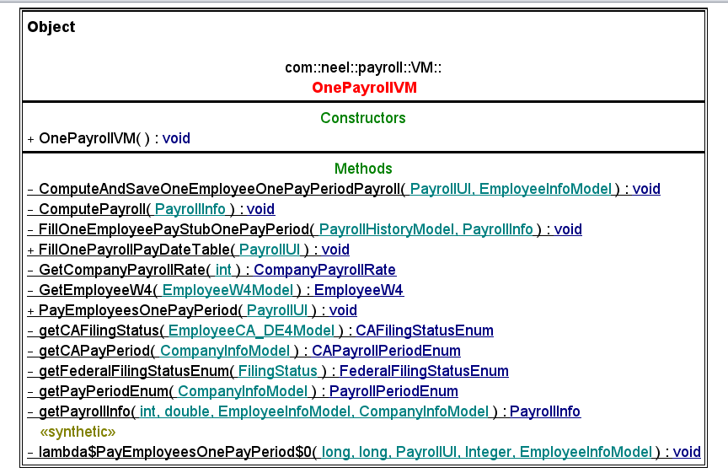

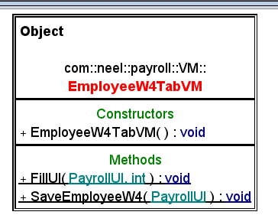

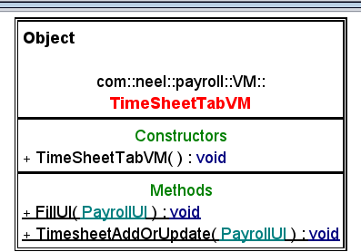

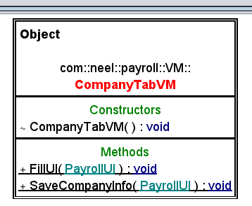

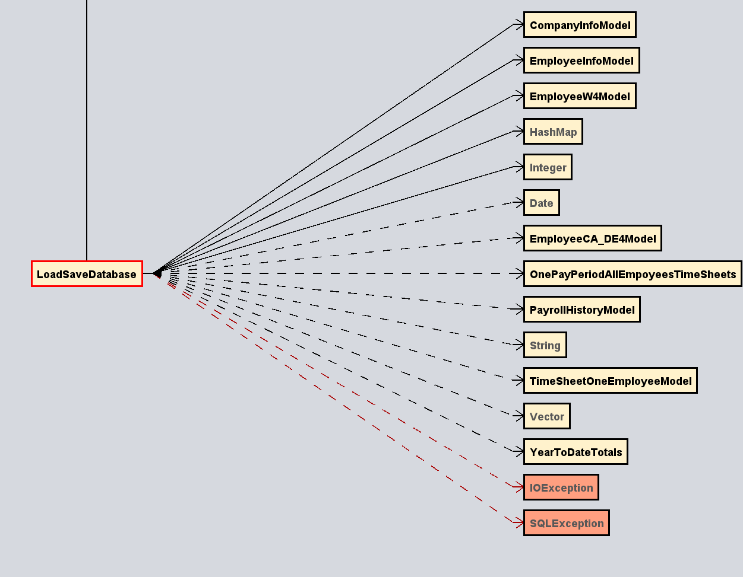

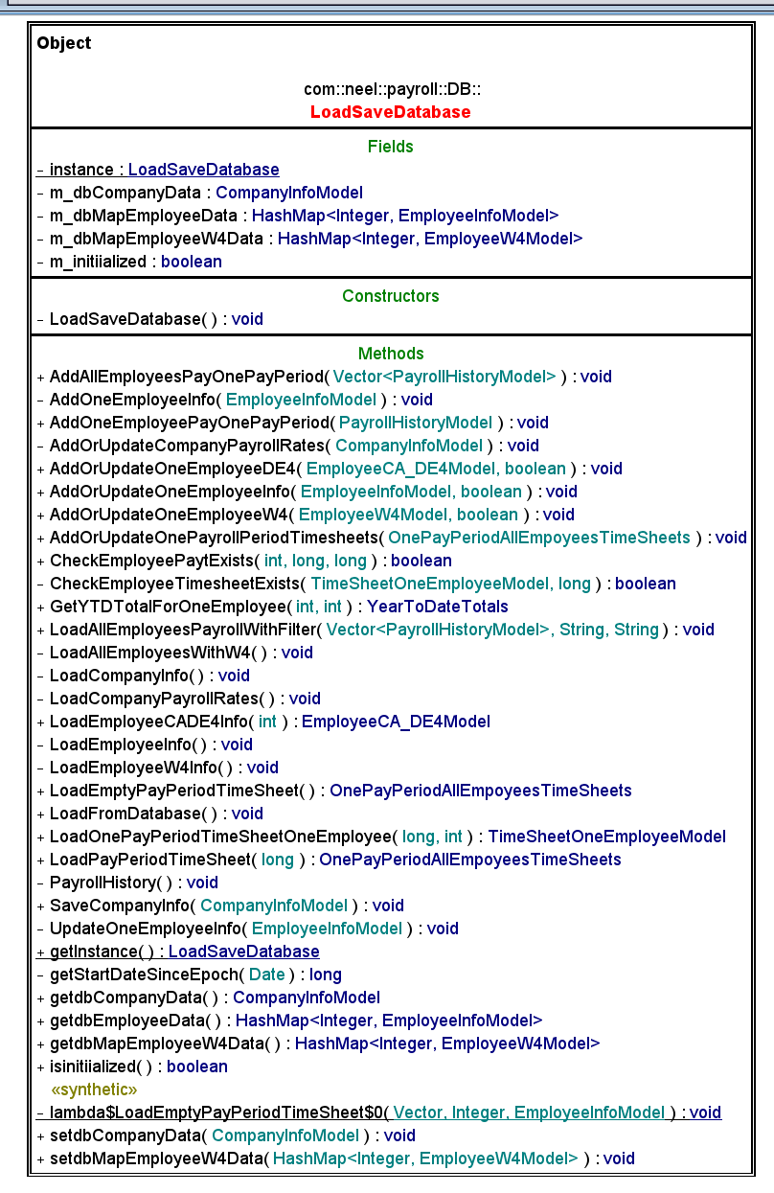

**Main classes used in PayrollLibrary**

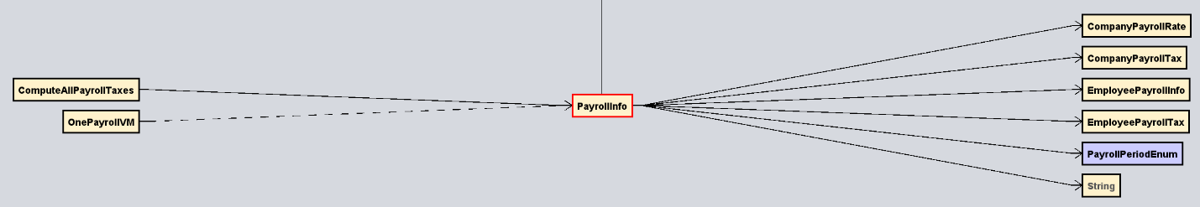

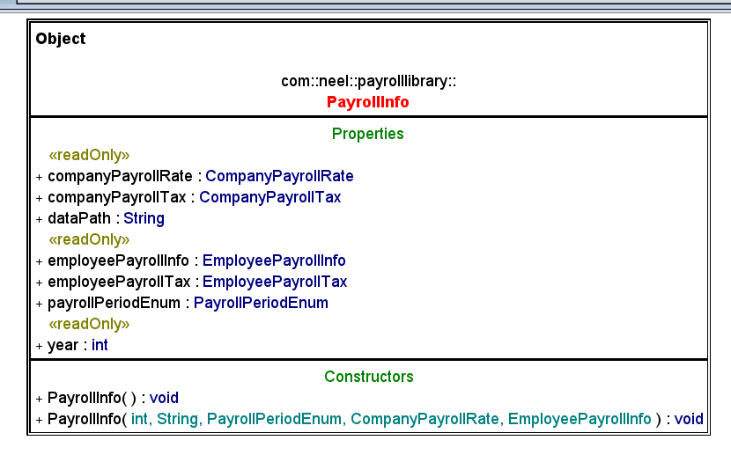

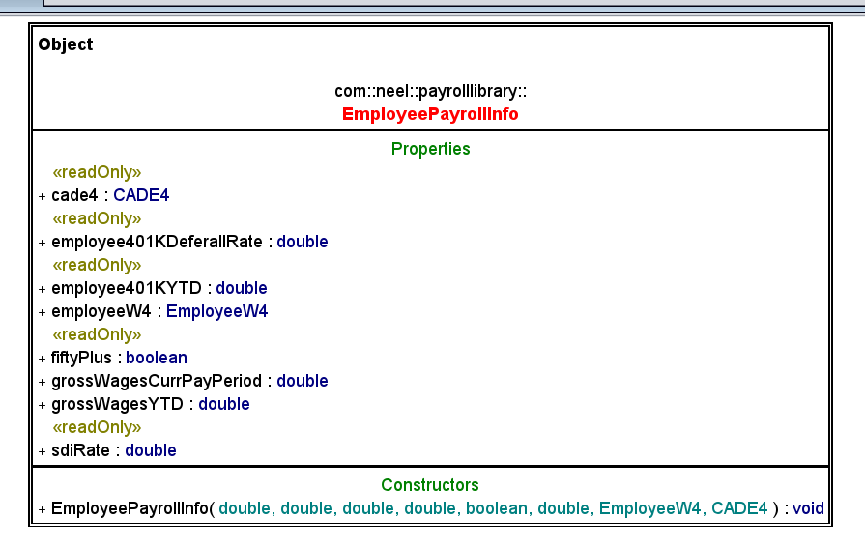

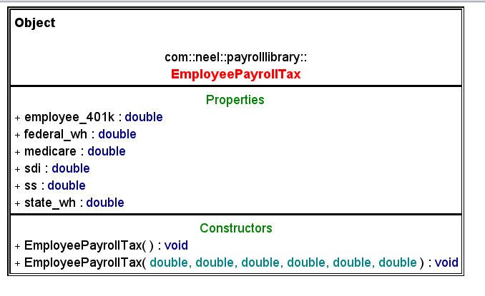

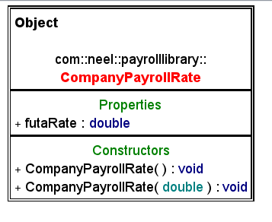

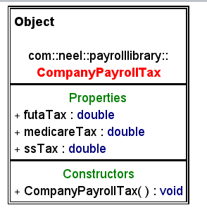

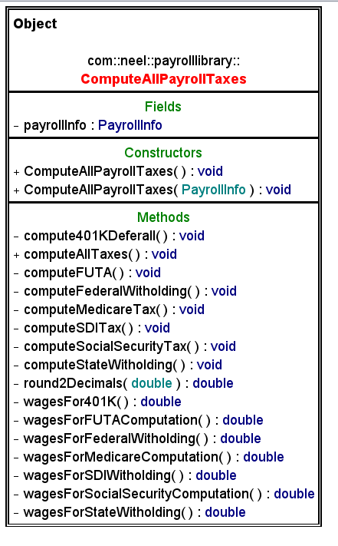

**External Data file generated from IRS publication 15* and California DE44**

